You are invited to….

When:

Where:

Notes:
eg Please wrap and bring a “pre-loved” book, DVD or toy as a gift for a neighbour

Please reply to:

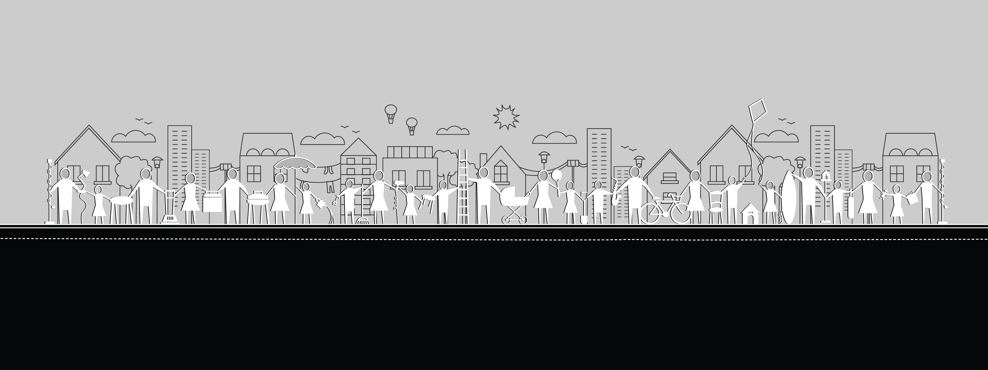
You are invited to….

When:

Where:

Notes:
eg Please wrap and bring a “pre-loved” book, DVD or toy as a gift for a neighbour

Please reply to:

